The Relationship between the internal pressure and the elasticity of a Volleyball

**1. Research Design**

**1.1 Introduction**

With all the 48[1] Sports in the Olympics there are Factors that can affect the athlete’s performance in their sport for example but not limited to the athletes physical Fitness through training and nutrition, Weather conditions, Event Schedule & Equipment. Those Factors can be classified under two main Categories, modifiable Factors, where athletes have control over it and fixed Factors, where athletes’ influence is limited.

Depending on the Sport, each factor that influences the athlete’s performance is interchangeable under those two categories. For example, in golf, instead of players using a standard golf club, they can customize it to their preferences. In Volleyball, on the other hand, Field Size, Net height, Internal Pressure and Size of the Ball cannot be adjusted to the players' liking but are rather standardized according to the FIVB[2] regulations.

For me, personally was the most exciting factor of all, the Volleyball internal pressure. The Volleyball internal pressure is very important because it changes the elasticity of the Volleyball, which affect its bounce height, rebound height, grip & speed, which are crucial Factors for any Volleyball player.

Hence, I wanted to test and observe the Relation between the internal pressure and the elasticity of a Volleyball at six consecutive bounces.

**1.2 Research question**

How does the internal pressure of a Volleyball (5.2 psi, 4.5 psi, 3.5 psi, 2.5 psi, 2.0 psi) affect its rebound height at six consecutive bounces to determine its influence on the elasticity of Volleyball through the measurements of its consecutive coefficients of restitution?

**1.3 Background information**

The Ball goes through 3 different Phases. The first phase starts while the Ball is at its initial height where it stores Gravitational potential energy Ep. The GPE is the energy an object has because of its position in a gravitational field (Oxford, 2024). The GPE of an object is determined by:

$$\begin{aligned}E_{p}=mgh\#\left(1\right)\end{aligned}$$

Where:

Ep = Gravitational Potential Energy (J)

m = Mass of the object (kg)

g = Gravitational Field strength (ms-2)

h = Height to the ground relative to a specific reference point (m)

The equation of GPE is only relevant to objects that are close to the Earth’s surface, because g = 9.81 ms-2 varies from the location of the measurement.

When the object is released from its initial height, the object stores energy because of its motion, the Kinetic Energy (Oxford, 2024), which is determined by:

$$\begin{aligned}E_{k}=\frac{1}{2}mv^{2}\#\left(2\right)\end{aligned}$$

Where:

Ek = Kinetic Energy (J)

m = Mass of the object (kg)

v = Velocity of the Object (ms-1)

The law of Conservation of Energy states that energy cannot be created nor destroyed, only transformed from one form to another[3].

According to the Law of Conservation of Energy, before the Object falls, the GPE is at its maximum because the object is at its maximum height therefore the Objects KE is 0, thus velocity = (0 ms-1).

Right before the Collision with the ground, the GPE is entirely converted to KE. From this point the object starts the second Phase.

According to newton’s 3rd law, the gained force from the ball’s fall will exert a force on the ground that leads the ground to exert an equal and opposite force. From this reaction the KE of the ball converts into elastic potential energy.

The Elasticity of an object is described in Hooke’s law, which states that the restoring force exerted by an elastic object is proportional to how far it has been distorted from its equilibrium position (Oxford, 2024).

$$F_{H}=-kx$$

Where:

FH = Restoring Force (N or kgms-2)

k = Spring constant (Nm-1 or kgs-2)

x = Displacement of the spring from its equilibrium position (ms-1)

When distorting an elastic object from its equilibrium shape by extending or contracting, work must be done, therefore the object stores elastic potential energy. This is applied in the investigation with volleyball, where elasticity of the ball’s material comes due to the intermolecular force inside of the ball.

The intermolecular force inside of the ball depends on the Pressure inside of the ball. Pressure is the Force exerted by a fluid on a unit area of a surface (Oxford 2024). By pumping air into the Volleyball, the pressure inside of the ball increases, which results to an increase in ball elasticity.

$$P=\frac{F}{A}$$

Where:

P = Pressure (Pa or Nm-2)

F = Force (N)

A = Area (m2)

The Elasticity increases due to the difference between the air pressure inside of the ball and outside of the ball.

The Ball is deformed, which leads to an increase in the elastic potential energy, thus the KE that the ball gained before the collision converts partially into elastic potential Energy during the collision with the ground according to the law of conservation of Energy.

Some of the KE is lost due to converting the KE into thermal energy due to internal friction of the material’s particles, sound etc.

At some point the internal forces caused by pressure inside of the ball resists being deformed, which leads to less energy loss because the object goes back to the equilibrium position more efficiently. After the Collision with the ground the Ball comes momentarily at rest and goes into the third phase.

In the phase after the collision with the ground the same reaction in phase one repeats in a descending order. The EPE from the ball will deform the ball into going to its equilibrium position. The EPE will convert into KE and then will be decreased and converted to GPE according to the law of conservation of Energy.

Some of the EPE get lost again due to thermal energy, friction or sound, which leads to less total energy. This is calculated by the coefficient of restitution of the ball through the Experiment.

The Coefficient of restitution is the ratio of the velocity components along the normal plane of contact after and before the collision.

$$e=\frac{v_{final}}{v_{initial}}$$

Where:

e = coefficient of restitution (Unitless)

vfinal/initial = Velocity of the Object (ms-1)

3 types of elasticity are conducted from the coefficient of restitution, the perfectly inelastic collisions, where the coefficient of restitution equals to 0 & the KE is lost, the perfectly elastic collisions where the coefficient of restitution equals to 1 and no KE is lost, the inelastic collisions, where the coefficient of restitution is between 0 & 1.

The Kinetic and the Gravitational potential energy are connected through this equation according to the law of conservation of energy:

$$gravitational potential energy=Kinetic Energy$$

$$mgh =\frac{1}{2}mv^{2}$$

The following equation may be rearranged for the velocity:

$$v =\sqrt{2gh}$$

Since the coefficient of restitution is based on the velocity at two points, the coefficient of restitution equation could be written as follows:

$$e=\frac{v_{final}}{v_{initial}}$$

$$e=\frac{\sqrt{2gh_{final}}}{\sqrt{2gh_{initial}}}$$

Hence, the coefficient of restitution is described as the square root of the final height reached by the object divided by the initial height of the object:

$$\begin{aligned}e=\sqrt{\frac{h_{final}}{h_{initial}}}\#\left(11\right)\end{aligned}$$

Where:

e = coefficient of restitution (Unitless)

hfinal/initial = height of the Object (m)

**1.4 Hypothesis**

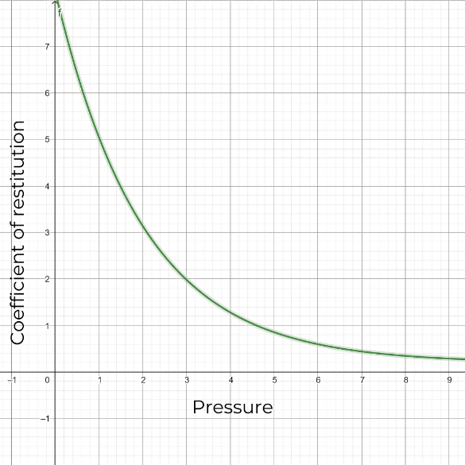Through the information presented, we can hypothesize that as the internal pressure of a Volleyball increases, the rebound height over six consecutive bounces will increase, because the higher the pressure is, the higher the intermolecular force in the ball is, thus enhances the elasticity of the ball which leads to a more efficient energy transfer during the collisions with the ground. Thus, the coefficient of restitution will be higher at higher pressures. Holding into account the smaller effect of the intermolecular Forces of the ball on its coefficients of restitution at higher pressures, the graph will start decreasing after one point and continues to a decreasing rate to tend towards a specific limit.

Figure 1: Hypothetical relationship between the Pressure and the coefficient of restitution (self-designed using GeoGebra & Canva)

Null hypothesis (H0):

The internal pressure of the volleyball doesn’t in fact significantly affect its rebound height over six consecutive bounces, thus, the relationship between the internal pressure and the coefficient of restitution is not existent nor can be calculated.

Alternative Hypothesis(H1):

The internal pressure of the volleyball does affect its rebound height over six consecutive bounces, thus, the relationship between the internal pressure and the coefficient of restitution can be calculated for each bounce.

**1.5 Variables**

| Manipulated and measured variables | | | |
| --- | --- | --- | --- |
| Variable | | Explanation & Justification | Apparatus |
| Independent variable | Internal Pressure | The Internal Pressure in the volleyball that will be changed as follows: 5.2 psi, 4.5 psi, 3.5 psi, 2.5 psi, 2.0 psi ensuring the variety throughout the experiment.  (all converted to kPA for better compatibility with SI units) | Volleyball pump with a Pressure gauge ( $±$ 0.01 bar based on the smallest increment in the analog instrument and human error in readings) |
| Dependent variable | Rebound height | The Rebound height of the volleyball over six consecutive bounces to calculate the coefficient of restitution | Video analysis software “Tracker”  ( $±$ 0.001 m due to the precision of the video analysis software) & a measuring tape for calibration purposes.  ( $±$ 0.001 m due to human error) |

| Controlled Variables | | | |
| --- | --- | --- | --- |
| Variable | Significance | Means of control | Justification |
| Type of Volleyball | The material/surface of the volleyball affects its elasticity and reaction with the surface as well. | Using the same volleyball for all trials. | Ensuring that the relationship between the internal pressure and the coefficient of restitution is not affected by any variable other than the independent (Internal Pressure) & dependent (rebound height) variables. |
| Drop height | Ensures consistent GPE and KE for each trial, which affects the volleyball’s rebound height. | Releasing the ball from a fixed height throughout the trials. (1.500 $±$ 0.001 m due to error in measurements). |
| Surface of impact | Inconsistency on the surface could affect the energy loss during each collision. | Conducting the experiment on concrete, a flat and hard surface across all trials. |
| Temperature | The elasticity of a material depends on the Temperature. | Conducting the trials in an indoor environment where the humidity & temperature difference is minimized across all trials.  (T = 22.0 $±$ 0.1 °C)  (Uncertainty due to the thermometer used to measure the room temperature). | The difference between the air pressure inside and outside the ball affects its elasticity, so maintaining a constant temperature through the trial is crucial |
| Humidity | Humidity affects the material’s properties which changes its elasticity. | Change in Humidity affects the volleyball and the surface, which eventually affects its rebound height. |
| Air composition | The change in the type of gas used affects its elasticity and pressure. | Inflating the Volleyball with standard air composition across trials.  (≈ 78% nitrogen,  ≈ 21% oxygen) | Using the same air composition ensures a valid comparison between the trials. |
| Video analysis setup | Variation in camera angle, lighting, light temperature could lead to errors in data collection. | Maintaining a consistent camera angle, height, lighting & light temperature and calibrate the software “Tracker” with a certain length throughout the trials. | Consistency in the video setup ensures accurate measurements of rebound height across all trials. |
| Bounce sequence timing | Interruption between bounces could affect measurements due to the volleyball’s reforming into original shape. | Allowing the Volleyball to complete all bounces in one trial. | Consistent bounce timing ensures minimizes the variability in results throughout all trials. |

|  |  |
| --- | --- |
| Controlled Variables | |
| Variable | **Significance** |
| Environmental factors | Minor air current changes, vibrations & external noise can affect the volleyball’s rebound. |
| Material aging | Repeated trials slightly change the Volleyball’s elasticity which impacts the results over time. |
| Surface imperfections | Uneven surfaces could cause slight deviations in rebound height. |

**1.6 Materials**

1. Mikasa V330W Volleyball (Diameter 20.7 - 21.3 cm | Weight 260 – 280 g)
2. Pressure Gauge ( $±$ 0.01 bar)
3. Electric air pump
4. 1 meter of Sewing Measuring tape ( $±$ 0.005 meter)
5. Paper
6. Marker
7. Scissors
8. Smartphone
9. Tripod
10. Marking Tape ( $±$ 0.005 meter)
11. Flat, Hard Surface
12. Video analysis software “Tracker”[4]
13. Laptop

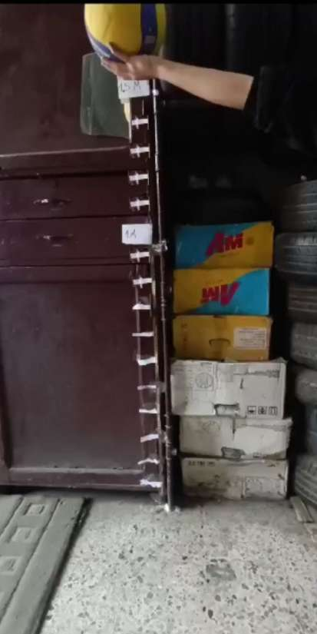**1.7 Method**

1. Attach the Sewing measuring tape vertically against a flat wall with the tape.
2. Cut the Paper into two big pieces.
3. Mark the Papers with 1- & 1.5-meter with the marker
4. Attach the markers to the wall with the height of the marker.
5. Cut another paper into fifteen slim pieces.
6. Attach the fifteen slim pieces to the wall with a 10 cm gap.
7. Inflate the Volleyball fully.
8. Connect the Volleyball to the pressure gauge and adjust the internal pressure to the required level
9. Setup the smartphone on the tripod perpendicular to the wall
10. Setup the smartphone into Video mode
11. Release the Volleyball from the 1.5-meter mark (measured from the bottom of the ball) and start recording the first 6 consecutive bounces.
12. Insert the Videos into “Tracker”
13. Add & adjust the Coordinate axes to align with the floor and the wall from the tool’s menu.
14. Add a 1.5-meter calibration stick from the menu and adjust it with the Coordinate axes, the floor, and the wall.
15. Track the Volleyball through each frame and the data will be shown automatically to the right of the screen through a table and an x & y-coordinate.
16. Repeat Point 7-15 for the 6 different pressures and for 5 trials.

**1.8 Preliminary Trials**

While preparing the experiment, preliminary trials were conducted to identify potential challenges and optimize the experimental conditions to minimize data errors. One of the main issues was the automatic warp that any camera does that would manipulate the data if ignored. This issue was solved partially through attaching the camera to a tripod and making sure it’s perpendicular to the wall. Another issue was the ball moving horizontally, which made it difficult to analyze the data through the Smartphone camera because the Volleyball would go out of frame, therefore air movements in the room were minimized to ensure the consistency of the data obtained.

**1.9 Risk assessment**

|  |  |
| --- | --- |
| Consideration Type | Significance |
| Safety Considerations | Safety considerations were taken through ensuring the volleyball is inflated to a safe pressure range to prevent over-inflation and the volleyball’s burst, which will increase the risk of injury from the flying fragments.  Handling also the air pump carefully to avoid any release of air that could cause an injury. |
| Ethical Considerations | The experiment does not involve ethical considerations as there was no animal use and the data was not collected from human participants. |
| Environmental Considerations | While pumping Volleyball there were single-use pumps and gloves used to reduce waste and promote sustainability.  After the experiment, the Volleyball was donated to a refugee camp for free to reduce waste by repurposing volleyball as sports equipment for the children. This minimizes the environmental impact. |

**2. Analysis**

**2.1 Data collection**

**2.1.1 Qualitative data**

The results were plotted using the video analysis software “Tracker”.

Figure 2: Data analysis (graph obtained using "Tracker") for trial 1 (5.2 PSI OR 35.85 kPa)

The graph shows the maximum height achieved of the Volleyball through six consecutive bounces. At the start of the graph the initial height of the Volleyball is pointed out (1.5 meters). The height of the volleyball decreases until hitting the ground. The Volleyball then goes upwards and reaches a new height which is the final height of the ball after the first bounce. This reaction is repeated until the ball reaches the sixth consecutive bounce or goes to rest.

**2.1.2 Quantitative data**

Table 1: Raw data tables of the Experiment in five different pressures through 5 Trials

|  |  |  |  |  |  |  |  |  |
| --- | --- | --- | --- | --- | --- | --- | --- | --- |
| Pressure in PSI  ($±$ 0.14 PSI) | Pressure in kPa  ($±$ 0.6 kPa) | Trial number | Rebound height in meter ($±0.02$) | | | | | |
| Number of bounces (n) | | | | | |
| **1** | **2** | **3** | **4** | **5** | **6** |
| 5.2 | **35.85** | **1** | 1.277 | 0.933 | 0.724 | 0.617 | 0.500 | 0.353 |
| 4.5 | **31.02** | 0.939 | 0.652 | 0.544 | 0.391 | 0.284 | 0.228 |
| 3.5 | **24.13** | 0.906 | 0.529 | 0.333 | 0.229 | 0.193 | 0.182 |
| 2.5 | **17.23** | 0.848 | 0.578 | 0.386 | 0.291 | 0.229 | 0.202 |
| 1.5 | **10.34** | 0.466 | 0.262 | 0.198 | 0.159 | 0.153 | 0.149 |
|  |  |  |  |  |  |  |  |  |
| 5.2 | **35.85** | **2** | 1.299 | 0.952 | 0.745 | 0.621 | 0.511 | 0.336 |
| 4.5 | **31.02** | 0.926 | 0.643 | 0.569 | 0.379 | 0.296 | 0.228 |
| 3.5 | **24.13** | 0.896 | 0.562 | 0.332 | 0.262 | 0.124 | 0.176 |
| 2.5 | **17.23** | 0.810 | 0.576 | 0.358 | 0.276 | 0.232 | 0.235 |
| 1.5 | **10.34** | 0.476 | 0.269 | 0.112 | 0.137 | 0.129 | 0.112 |
|  |  |  |  |  |  |  |  |  |
| 5.2 | **35.85** | **3** | 1.253 | 0.932 | 0.721 | 0.615 | 0.556 | 0.372 |
| 4.5 | **31.02** | 0.921 | 0.631 | 0.525 | 0.352 | 0.263 | 0.215 |
| 3.5 | **24.13** | 0.916 | 0.525 | 0.365 | 0.226 | 0.173 | 0.137 |
| 2.5 | **17.23** | 0.873 | 0.543 | 0.331 | 0.253 | 0.262 | 0.215 |
| 1.5 | **10.34** | 0.461 | 0.263 | 0.197 | 0.151 | 0.156 | 0.144 |
|  |  |  |  |  |  |  |  |  |
| 5.2 | **35.85** | **4** | 1.271 | 0.928 | 0.726 | 0.601 | 0.525 | 0.332 |
| 4.5 | **31.02** | 0.942 | 0.615 | 0.516 | 0.371 | 0.277 | 0.236 |
| 3.5 | **24.13** | 0.901 | 0.529 | 0.331 | 0.213 | 0.163 | 0.136 |
| 2.5 | **17.23** | 0.804 | 0.536 | 0.382 | 0.236 | 0.237 | 0.215 |
| 1.5 | **10.34** | 0.466 | 0.262 | 0.198 | 0.159 | 0.153 | 0.149 |
|  |  |  |  |  |  |  |  |  |
| 5.2 | **35.85** | **5** | 1.238 | 0.952 | 0.724 | 0.616 | 0.552 | 0.363 |
| 4.5 | **31.02** | 0.959 | 0.664 | 0.572 | 0.361 | 0.291 | 0.232 |
| 3.5 | **24.13** | 0.911 | 0.573 | 0.352 | 0.272 | 0.173 | 0.153 |
| 2.5 | **17.23** | 0.835 | 0.532 | 0.372 | 0.282 | 0.262 | 0.236 |
| 1.5 | **10.34** | 0.427 | 0.297 | 0.182 | 0.152 | 0.162 | 0.173 |

The uncertainty used in the Pressure columns are according to the pressure gauge manufacturer’s specifications, which states that the uncertainty is = $±$ 0.14PSI, which is converted to kPa to ensure accurate data alignment in table 1.

The uncertainty used in the rebound height column is according to the human reading error of the height in “Tracker” the video analysis software.

**2.2 Data Processing**

The data acquired by the experiment was first processed by calculating the average maximum height of each bounce through the 5 trials in the 5 different pressures. The average maximum height was calculated through the sum of trial values divided by the number of trials which are 5 in each bounce.

$$\overline{h}=\frac{\sum_{i=1}^{n}{h_{i}}}{n}$$

Where:

$\overline{h}$ = the average height (meter)

$h_{i}$ = the height of in the $i$-th trial (meter)

$n$ = number of trials (in this experiment = 5)

The average height of each bounce in each pressure will then be calculated into the derived formula acquired from the background information section of the Coefficient of restitution.

$$e=\sqrt{\frac{h_{final}}{h_{initial}}}$$

For bounce 1:

$$e=\sqrt{\frac{\overline{h} }{1.500}}$$

For bounces from 2 to 6:

$$e_{j}=\sqrt{\frac{\overline{h} }{h_{j-1}}}$$

Where:

$h_{j-1}$ = $h_{initial}$ = $\frac{\sum_{i=1}^{n}{h_{i,j-1}}}{n}$

$h_{j}$ = $h_{final}$ = $\frac{\sum_{i=1}^{n}{h_{i,j}}}{n}$

Thus, this general formula is acquired for all Bounces.

$$\begin{aligned}e=\sqrt{\frac{\frac{\sum_{i=1}^{n}{h_{i,j}}}{n}}{\left\{\begin{aligned}1.500 if j=1 \\ \frac{\sum_{i=1}^{n}{h_{i,j-1}}}{n} if j≥2\end{aligned}\right.}}\#\left(16\right)\end{aligned}$$

Table 2: Processed data out of the general formula acquired for all Bounces.

|  |  |  |  |  |  |  |  |  |  |  |  |  |  |  |  |
| --- | --- | --- | --- | --- | --- | --- | --- | --- | --- | --- | --- | --- | --- | --- | --- |
| Pressure in kPa  ($±$ 1 kPa) | Average rebound height in meters (m) | | | | | | |  | | Coefficient of restitution (unitless) | | | | | |
| Number of bounces (n) | | | | | | | | | | | | | | |
| **1** | **2** | **3** | **4** | **5** | **6** |  | | **1** | | **2** | **3** | **4** | **5** | **6** |
| 35.85 | 1.268 | 0.939 | 0.728 | 0.614 | 0.529 | 0.351 | 0.919 | | 0.861 | 0.880 | 0.918 | 0.928 | 0.815 |
| 31.02 | 0.937 | 0.641 | 0.545 | 0.371 | 0.282 | 0.228 | 0.791 | | 0.827 | 0.922 | 0.825 | 0.872 | 0.898 |
| 24.13 | 0.906 | 0.544 | 0.343 | 0.240 | 0.165 | 0.157 | 0.777 | | 0.775 | 0.794 | 0.838 | 0.829 | 0.974 |
| 17.23 | 0.834 | 0.553 | 0.366 | 0.268 | 0.244 | 0.221 | 0.746 | | 0.814 | 0.813 | 0.855 | 0.956 | 0.950 |
| 10.34 | 0.459 | 0.271 | 0.177 | 0.152 | 0.151 | 0.145 | 0.553 | | 0.768 | 0.810 | 0.924 | 0.997 | 0.983 |

Second, by processing the data, the rebound height’s absolute uncertainty is calculated by subtracting the maximum height value with the minimum height value of the desired bounce & pressure and dividing it by 2.

$$\begin{aligned}△h=\frac{\left(h_{max}-h_{min}\right)}{2}\#\left(17\right)\end{aligned}$$

where:

$△h$ = Rebound height’s absolute uncertainty (Unitless)

$h_{max/min}$ = height (meter)

Third, the Fractional/Relative uncertainty of the rebound height is based on its absolute uncertainty where the fractional uncertainty is the absolute uncertainty divided by the magnitude of the quantity.

$$\begin{aligned}\frac{△h}{h}\#\left(18\right)\end{aligned}$$

Table 3: Absolute and Relative Uncertainty of the rebound height based on the experimental data.

|  |  |  |  |  |  |  |  |
| --- | --- | --- | --- | --- | --- | --- | --- |
| Pressure (kPa) | Uncertainty Type | 1st Bounce | 2nd Bounce | 3rd Bounce | 4th Bounce | 5th Bounce | 6th Bounce |
| 35.85 kPa | Absolute | 0.03 | 0.01 | 0.01 | 0.01 | 0.03 | 0.02 |
| Relative | 0.02 | 0.01 | 0.01 | 0.01 | 0.02 | 0.02 |
| 31.02 kPa | Absolute | 0.02 | 0.02 | 0.03 | 0.02 | 0.02 | 0.01 |
| Relative | 0.02 | 0.03 | 0.03 | 0.02 | 0.02 | 0.01 |
| 24.13 kPa | Absolute | 0.01 | 0.02 | 0.02 | 0.03 | 0.02 | 0.02 |
| Relative | 0.01 | 0.03 | 0.02 | 0.03 | 0.03 | 0.03 |
| 17.23 kPa | Absolute | 0.03 | 0.02 | 0.03 | 0.03 | 0.02 | 0.02 |
| Relative | 0.04 | 0.03 | 0.03 | 0.03 | 0.02 | 0.02 |
| 10.34 kPa | Absolute | 0.02 | 0.02 | 0.04 | 0.01 | 0.02 | 0.03 |
| Relative | 0.05 | 0.04 | 0.09 | 0.02 | 0.04 | 0.07 |

In the calculations of the absolute and fractional uncertainty of the Coefficient of restitution the operation is more complicated, where the fractional uncertainty in the Coefficient of restitution is derived using the propagation of uncertainties for a square root[5].

Where:

Thus, the uncertainty of g is derived using the addition of fractional uncertainties:

$$\frac{g}{g}=\frac{△h_{final}}{h_{final}}+\frac{△h_{initial}}{h_{initial}}$$

By Substituting $\frac{g}{g}$ into the propagation of uncertainties we got:

$$\begin{aligned}\frac{△e}{e}=\frac{1}{2}\left(\frac{△h_{final}}{h_{final}}+\frac{△h_{initial}}{h_{initial}}\right)\#\left(21\right)\end{aligned}$$

Where:

$\frac{△e}{e}$ = Fractional uncertainty of the coefficient of restitution (Unitless)

By multiplying the Fractional uncertainty with the coefficient of restitution the absolute uncertainty of the coefficient of restitution is acquired.

$$\begin{aligned}△e= \frac{△e}{e}∙e\#\left(22\right)\end{aligned}$$

Table 4: Absolute and Relative Uncertainty of the coefficient of restitution based on the experimental data.

|  |  |  |  |  |  |  |  |
| --- | --- | --- | --- | --- | --- | --- | --- |
| Pressure (kPa) | Uncertainty Type | 1st Bounce | 2nd Bounce | 3rd Bounce | 4th Bounce | 5th Bounce | 6th Bounce |
| 35.85 kPa | Absolute | 0.01 | 0.01 | 0.01 | 0.01 | 0.01 | 0.02 |
| Relative | 0.02 | 0.02 | 0.01 | 0.01 | 0.02 | 0.02 |
| 31.02 kPa | Absolute | 0.01 | 0.02 | 0.03 | 0.02 | 0.02 | 0.01 |
| Relative | 0.02 | 0.03 | 0.03 | 0.03 | 0.02 | 0.02 |
| 24.13 kPa | Absolute | 0.01 | 0.02 | 0.02 | 0.02 | 0.02 | 0.03 |
| Relative | 0.01 | 0.02 | 0.03 | 0.03 | 0.03 | 0.03 |
| 17.23 kPa | Absolute | 0.02 | 0.03 | 0.02 | 0.03 | 0.03 | 0.02 |
| Relative | 0.03 | 0.04 | 0.03 | 0.03 | 0.03 | 0.02 |
| 10.34 kPa | Absolute | 0.02 | 0.03 | 0.05 | 0.06 | 0.05 | 0.05 |
| Relative | 0.03 | 0.05 | 0.07 | 0.07 | 0.06 | 0.06 |

**2.3 Data Visualization**

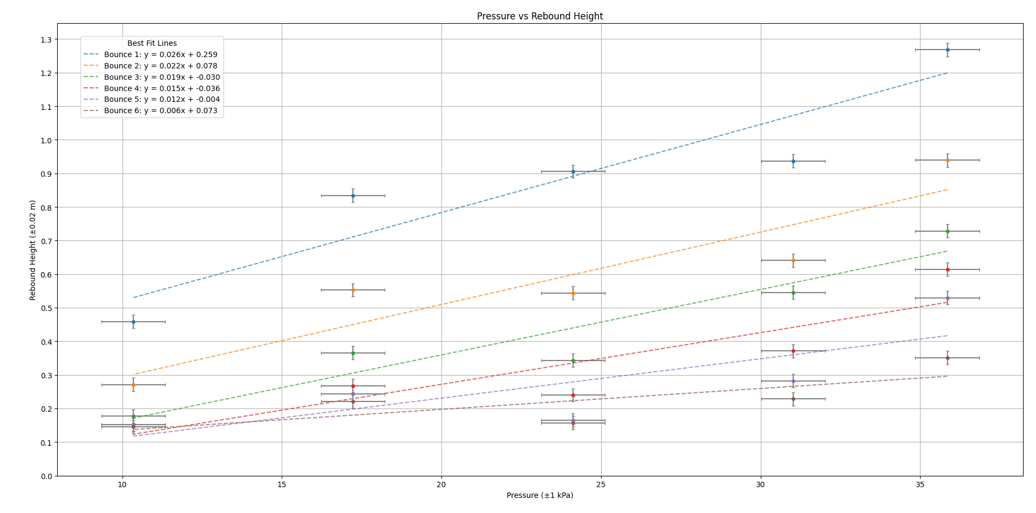

Graph 1: Data Visualization of the internal Pressure and its relationship with the Rebound Height within 6 consecutive bounces (self-coded using python libraries matplotlib & numpy) (Appendix A)

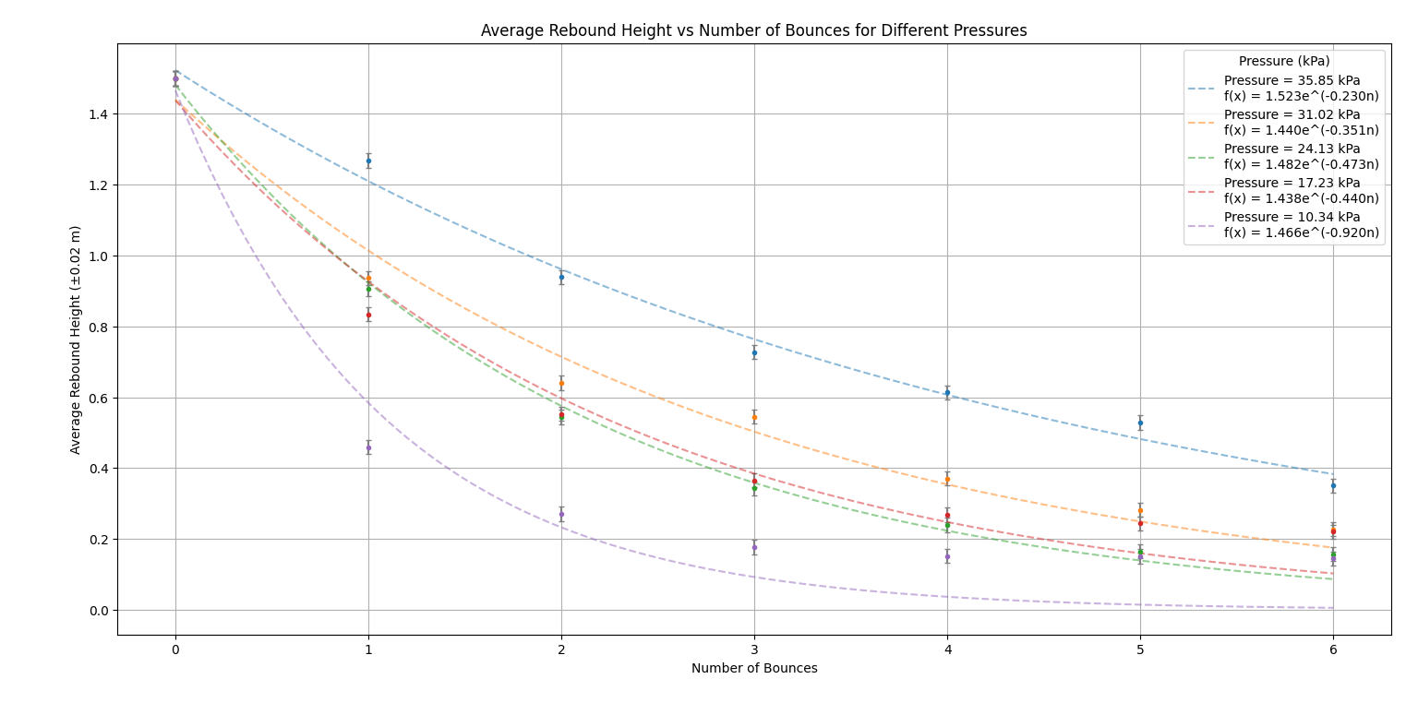

Graph 2: Data Visualization of the number of Bounces and its relationship with the Average Rebound height within 6 consecutive bounces (self-coded using python libraries matplotlib, numpy & scipy.optimze) (Appendix B)

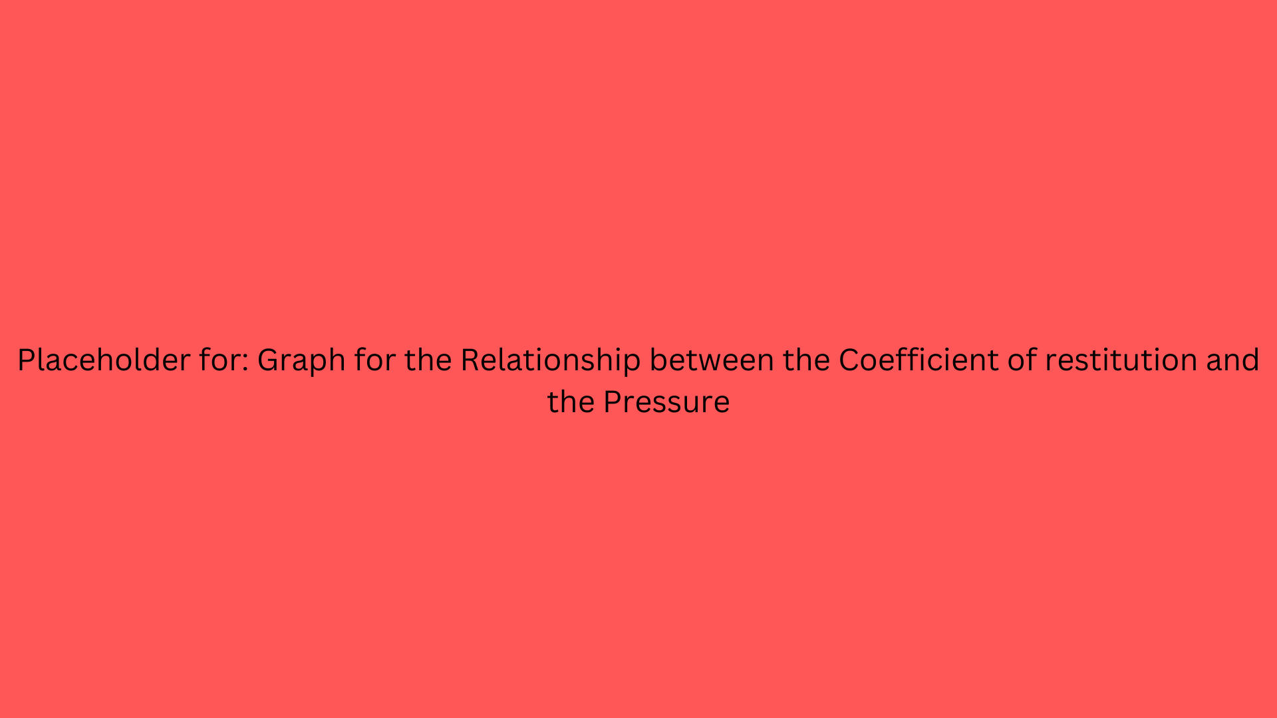

Graph 3: Data Visualization of the coefficient of restitution and its relationship with the the 5 Pressures used in the Experiment (self-coded using python libraries matplotlib, numpy & scipy.optimze) (Appendix B)

**3. Conclusion**

The aim for this investigation was to address the research qeustion

The statistical analysis of the data in graph 1 indicates that there is a positive linear Correlation between the internal pressure of the Volleyball tested and the maximum rebound height the Volleyball reaches. Although the points plotted on the graph and the best-fit line don’t align in all the cases, which results into a low precision, but the best-fit line shows the positive linear Correlation.

**4. Evalutation**

1. AKABAS, Lev. How summer Olympic sports have changed over time: Data viz. Sportico.com [online]. 23 July 2024. [Accessed 16 December 2024]. Available from: <https://www.sportico.com/leagues/olympics/2024/new-olympic-sports-2024-paris-1234775913/>
2. *Official Volleyball Rules 2021-2024 [online]. [Accessed 16 December 2024]. Available from:* [*https://www.fivb.com/wp-content/uploads/2024/03/FIVB-Volleyball_Rules_2021_2024_pe.pdf*](https://www.fivb.com/wp-content/uploads/2024/03/FIVB-Volleyball_Rules_2021_2024_pe.pdf)
3. *Law of conservation of energy - energy education* [online]. [Accessed 17 December 2024]. Available from: <https://energyeducation.ca/encyclopedia/Law_of_conservation_of_energy>
4. <http://physlets.org/tracker>
5. https://youtu.be/QR1qJX_bEG8?si=0CllgdTjK7FRTk4F